Panaligan, Judy A.
BSIT 2-F1

EXERCISE 2.
- Select * From employee_data where age > 30
- Select f_name, l_name From employee_data where title = ‘Web Designer’/
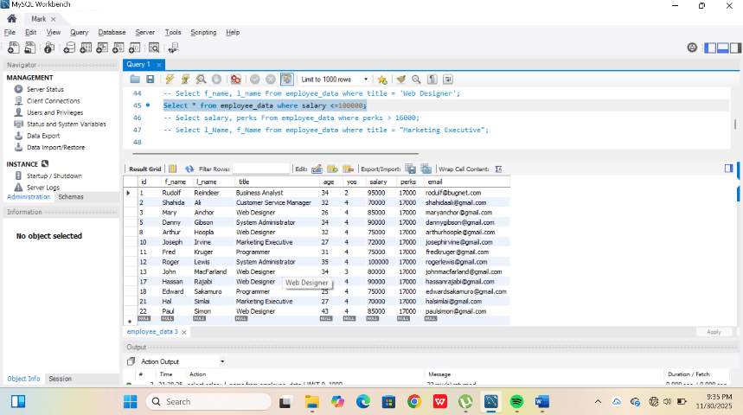

- Select salary, perks From employee_data where perks > 16000
- Select f_name, l_name From employee_data where title = ‘Marketing Executive’

